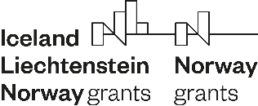


Call for proposals for co-financing of projects
under the programme Climate Change Mitigation and Adaptation

DECLARATION ON CONSULTANTS INVOLVED IN THE PREPARATION OF THE PROJECT APPLICATION

Information about the Project Promoter and its statutory representative:
Project acronym:
Name of the Project Promoter:
Address, postal code and town/city:
First name, surname and function of the statutory representative:

The following consultants, who are not employees of the Project Promoter or Project Partner, were involved in the preparation of the Project Application:
1. First name and surname: ………………………………………………………………………………………………………………………………………………....

Organisation: ……………………………………………………………………………………………………………………………….
2. First name and surname: ……………………………………………………………………………………………………………………………………………………

Organisation: .………………………………………………………………………………………………..........
3. First name and surname: ………………………………………………………………………………………………………………………………………….………

Organisation: ………………………………………………………………………………………………….....
(add if appropriate)

I, the undersigned, declare that the information given in this Declaration is true.

Place and date:  ________________________ |  | Signature of the statutory representative:  ____________________________
Stamp

(if a stamp is used)

