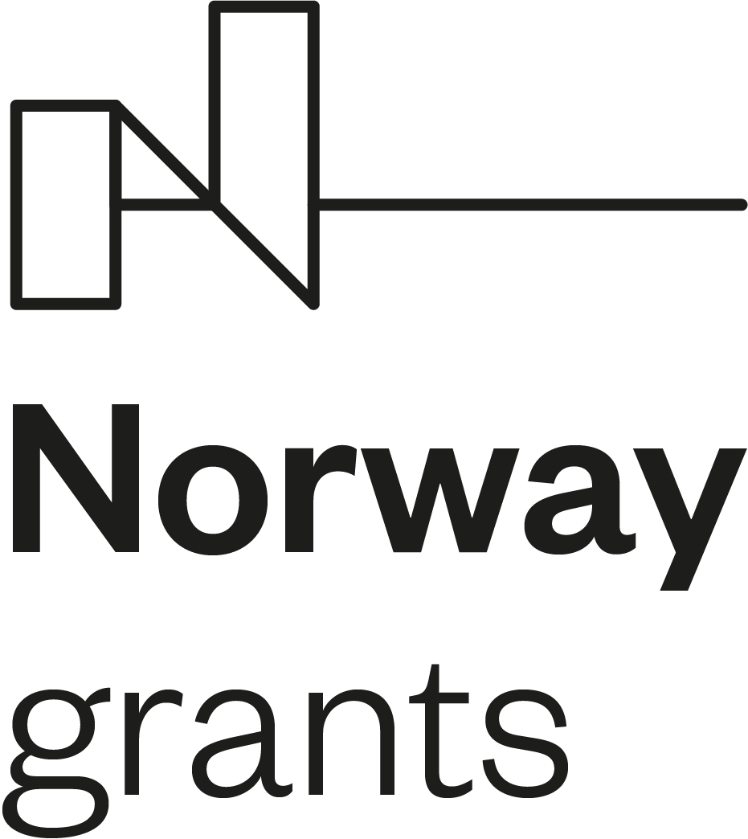

Call for proposals for co-financing of projects
under the programme Education, Scholarships, Apprenticeship and
Youth Entrepreneurship

DECLARATION BY THE PROJECT PROMOTER

I, the undersigned, ……. [first name and surname] acting as the statutory representative of …... [name of Project Promoter] in the role of the applicant of the Project ……. [Project acronym] under the programme Education, Scholarships, Apprenticeship and Youth Entrepreneurship (hereinafter referred to as the “Programme”) on behalf of and representing …... [name of Project Promoter] hereby declare that I agree with the conditions specified in the call for proposals and in the documentation relating to the call of proposals, and hereby confirm to accept these conditions.

Further on behalf of and representing …... [name of Project Promoter] hereby declare:

- I have been authorised by …... [name of Project Promoter] to submit a project application under the call for proposals and to enter into Contract on the award of the Financial Mechanisms grant and the matching national contribution (hereinafter referred to as the “Project Contract”) to be signed with the Programme Operator after the completion of the project proposals selection procedure on behalf of and representing …... [name of Project Promoter] as the Promoter of the Project ……. [Project acronym],
- the Project Promoter has been duly acquainted with the content of the legal bases defined as legal bases of this call for proposals and shall keep track of any potential amendment to the legal bases,
- the Project Promoter accepts the obligations under the abovementioned Project Contract to be signed with the Programme Operator after the completion of the project proposals selection procedure,
- if selected, the Project Promoter shall, while implementing the project, comply with the provisions of the call for proposals at all times during the project duration, and shall immediately inform the Programme Operator of any change to the project and the organisation that would in any way whatsoever affect the project vis-a-vis the project application submitted and the fulfilment of conditions of the call for proposals,
- the Project Promoter shall accept responsibility for the entire project; shall be responsible for the coordination, management and implementation of the project, shall bear in its relation to the Programme Operator exclusive financial responsibility for project implementation and shall bear sole responsibility for reimbursing funds to the Programme Operator in case of detected irregularities, contract termination, and other circumstances which, pursuant to the contract, call for reimbursement of the allocated funds,
- the Project Promoter shall not in any way, on their own or through related legal or natural persons, persons employed by the Project Promoter or persons who are members of the managing or supervisory authority of the Project Promoter, mediate, participate or in any other way be involved in the supply goods or the provision of outsourced services in relation to the project,
- the Project Promoter is the beneficiary of the Financial Mechanisms grant and the matching national contribution and shall manage the funds in accordance with the Partnership Agreement,
- the Project Promoter has taken note of the Programme rules pertaining to advance payments (only if the Project Promoter is governed by private or public law, established and operating as an association, private or public institute or institution) and reimbursement of Financial Mechanisms grant and the matching national contribution,
- the Project Promoter is any public or private entity, commercial or non-commercial, as well as non-governmental organisations, established and registered as legal entity in the Republic of Slovenia regardless of the legal organisational form and regardless of the nature of the activity it performs (gainful / non-gainful activity), which is entered in the Business Register of Slovenia at the time of publication of the call for proposals,
- the Project Promoter acknowledges that the fulfilment of conditions must be demonstrated in the entire project application and that such fulfilment shall be subject to continued verification during project implementation. If the project application fails to fulfil all set conditions, it shall be rejected. If the non-fulfilment of the set conditions is established only after the decision on the selection of project for funding, the project contract shall not be signed and the decision shall be annulled. If the non-fulfilment of the set conditions is established only after the signing of the project contract, the Programme Operator shall withdraw from the project contract and request recovery of the amounts unduly paid, including the default interest accrued from the date of receipt of the funds to the bank account to the date of recovery of the amounts unduly paid to the state budget of the Republic of Slovenia.

Place and date:  ________________________ |  | Signature and function of the statutory representative:  ____________________________  ____________________________

Stamp

(if a stamp is used)

