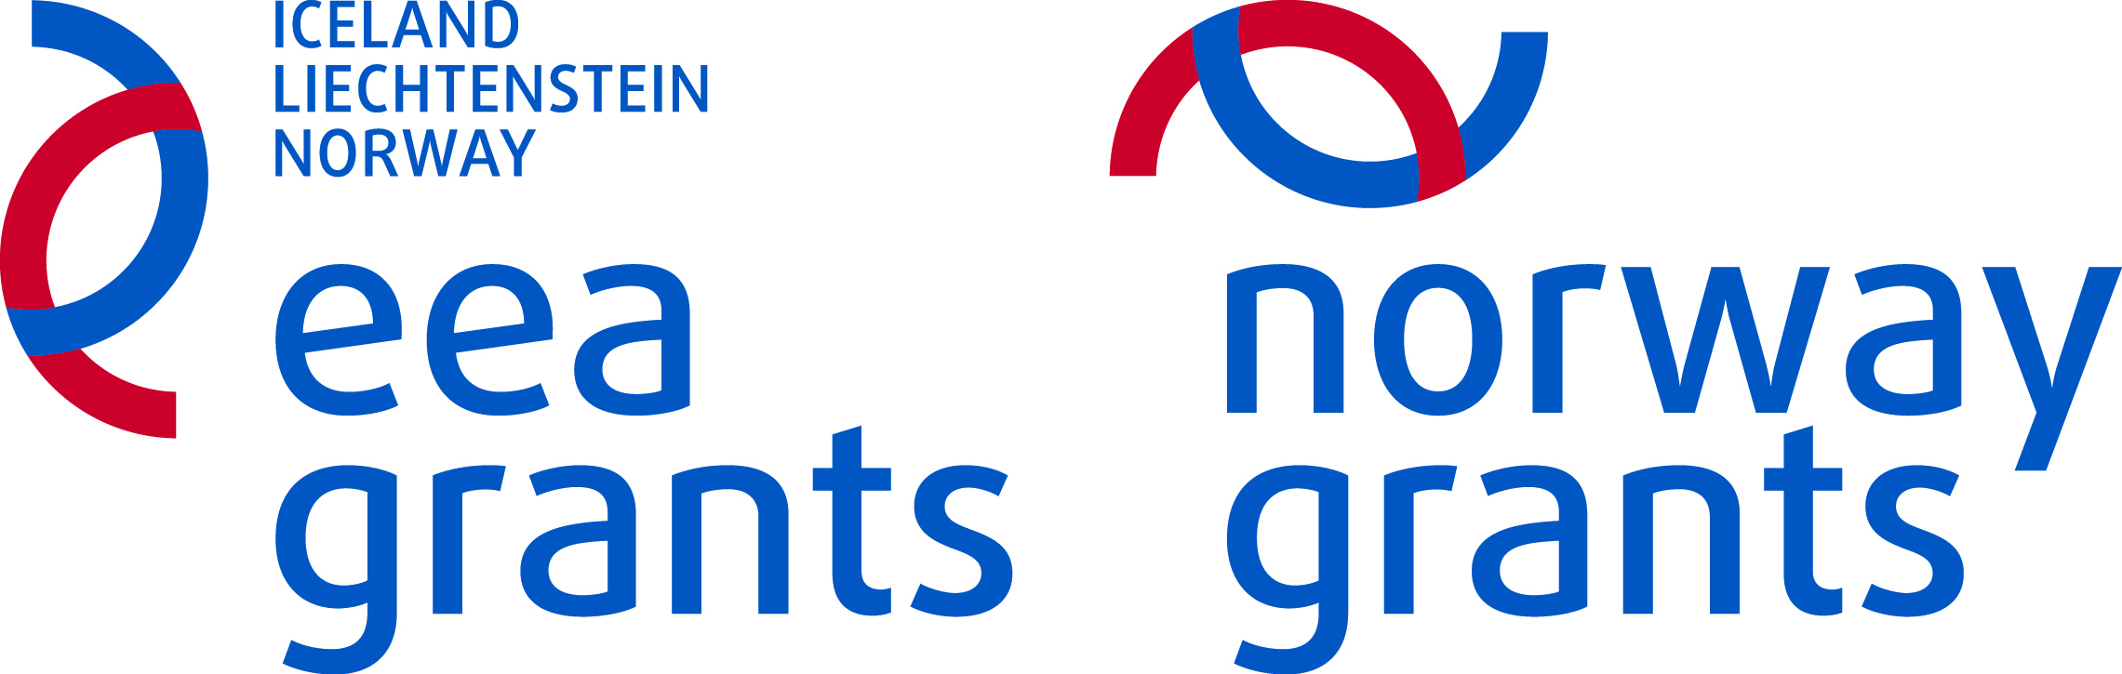


PARTNERSHIP STATEMENT – Set B
Project acronym:
Project title:

I, the undersigned, ………….., acting as the legal representative ………………… declare in the name of the partnership organisation that the partnership organisation, which I represent:
- ◻ | - is not subject to bankruptcy or liquidation, compulsory composition, has not ceased with its operation, is not subject to any proceedings related to the matters referred to above, nor is it in a related position, deriving from a similar procedure, foreseen within the national legislation or regulations  - has not been convicted by a final judgement of a criminal offence pertaining to its operation  - has met its obligations relating to the payment of social security contributions or benefits in accordance with the national legislative provisions  - we confirm the content and our role in the project................  - as a partner in the project, we accept the obligations arising from the contract on co-financing, which is signed by the Project Promoter in the event of approval of the project;  - we have the adequate legal, financial and operational capacity to implement the proposed project;  - we declare that we have not applied for and are not receiving other funding for the same project

Project Promoter and Project Partner agree on the following:
 | Project Promoter and Project Partner will define their rights and obligations in the Partnership Agreement which will take into account the provisions proposed by the Programme Operator.
 |  | Project Promoter |  | Project Partner
Name of the organisation:
Name and surname of the legal representative:
Function:
Signature:
Place and date:
Stamp:

